PHASE 4 – PROJECT PLANNING

4.1 Introduction
Project planning defines the development sequence, milestones, resources, risks, and expected deliverables for PocketSmart AI.

4.2 Project Scope
The project scope includes developing a web-based budget and recommendation assistant with user interaction, budget input, recommendation generation, database storage, and history/recent-plan functionality.

4.3 Development Approach
The project is developed in multiple stages:
- Brainstorming and ideation.
- Requirement analysis.
- System design.
- Project planning.
- Application development.
- Testing.
- Documentation.
- Demonstration.

4.4 Task Planning
Task | Description
Project Setup | Create project structure and environment
Backend | Develop FastAPI application
Database | Configure SQLite database
Authentication | Implement user authentication
UI | Develop application interface
Recommendation | Implement recommendation functionality
History | Store and display previous plans
Testing | Test application functionality
Documentation | Prepare project documentation
Demonstration | Record project demo

4.5 Technology Planning
The primary technologies planned for the application include Python, FastAPI, SQLite, HTML/CSS, JavaScript/templates, and Visual Studio Code.

4.6 Resource Planning
The required resources include:
- Development computer.
- Python environment.
- Visual Studio Code.
- Web browser.
- Project dependencies.
- Database.
- Internet connection when required.

4.7 Risk Identification
Possible project risks include:
- Dependency installation errors.
- Invalid user inputs.
- Backend errors.
- Database errors.
- Recommendation processing errors.
- UI integration problems.

4.8 Risk Mitigation
To reduce these risks:
- Dependencies are installed in a controlled virtual environment.
- Inputs are validated.
- Backend errors are tested.
- Database operations are verified.
- Application functionality is tested before demonstration.

4.9 Milestones
The project milestones are:
- Idea finalized.
- Requirements identified.
- System designed.
- Development planned.
- Application implemented.
- Application tested.
- Documentation completed.
- Demonstration prepared.
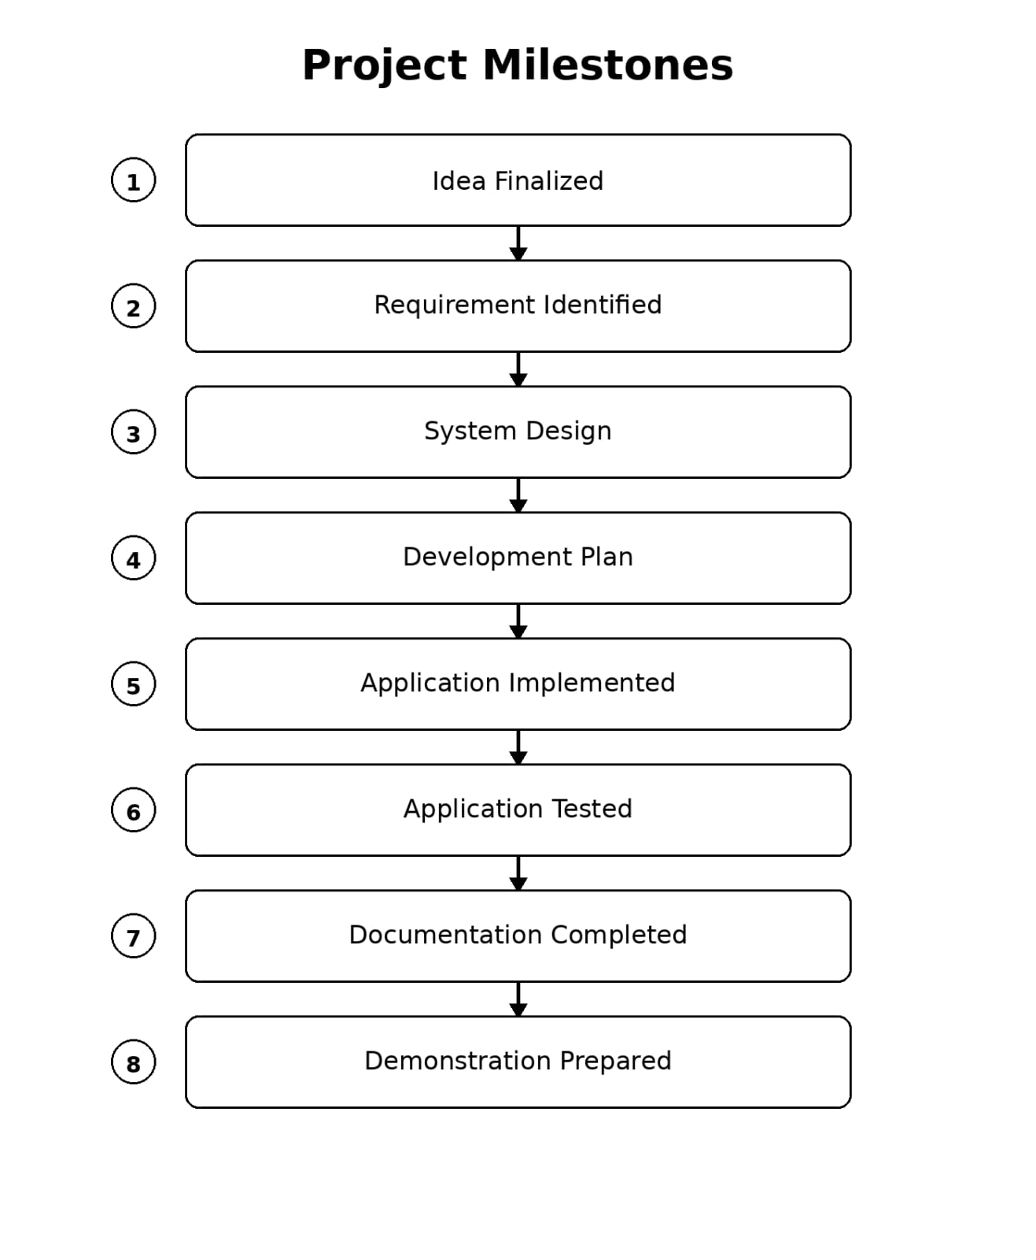

4.10 Expected Deliverables
The expected project deliverables are:
- Working PocketSmart AI application.
- Phase-wise documentation.
- Screenshots and testing evidence.
- Public GitHub repository.
- Project demonstration video.
- Google Drive demo video link.

